You may need to find and review course sections to help students prepare for registration. Use this reference to find current course sections.
At the end of this guide, you will see how this process works for students.

INSTRUCTIONS for FACULTY

- Login into Workday. To generate a list of current course sections using the search bar, type “Find [Academic Level] [Academic Period] Course Sections”. For example, in the search bar, type “Find Undergraduate Spring Course Sections” or “Find Graduate Course Fall Sections”.

The field will auto-populate suggestions.

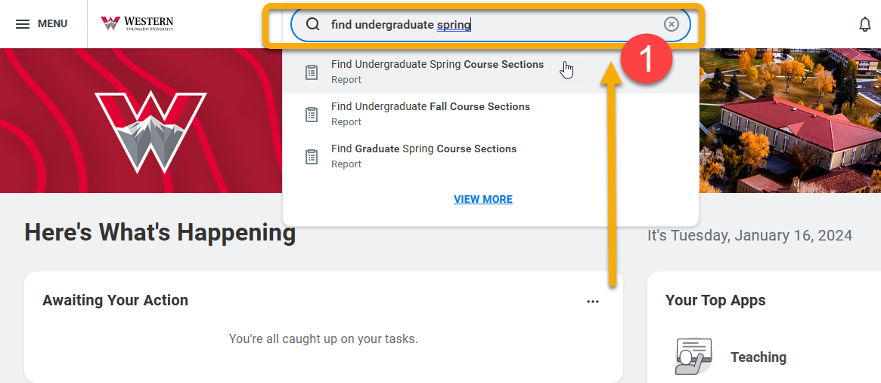
If you plan to search course sections often, you can make a shortcut. From the top-left menu, click “Shortcuts”, “Add Shortcuts” and type the name of the report, such as “Find Undergraduate Spring Course Sections” or “Find Graduate Fall Course Sections”.

- The Find Undergraduate/Graduate Course Sections page features two ways to search for courses: Search Bar and Left-hand Menu.

- Search Bar: To use the search bar, type keywords, subject (e.g. CHEM or ENG) or the exact course section (ENG 102 or ENG 102.03) and press Enter or click “Search”.

- Left-Hand Menu: Use this menu to filter results by criteria. Most commonly used search filters are Meeting Days and Section Status: Open, Waitlist, or Closed.

Additional filter options include:
- Instructor: Select specific instructors and view their course section assignments
- Instructional Format: This filter is helpful if you are looking for labs. Other formats include lecture, internship or independent study.
- Delivery Mode: Use this filter to view online or hybrid classes.

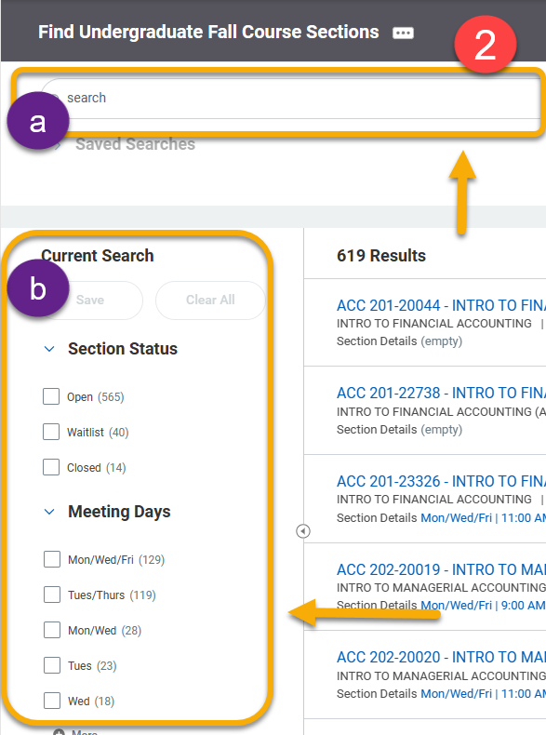

- Click the carrot symbol to the right of a course to view more course information.

- To view complete information, right-click the course title to open a new tab and select “See in New Tab”.
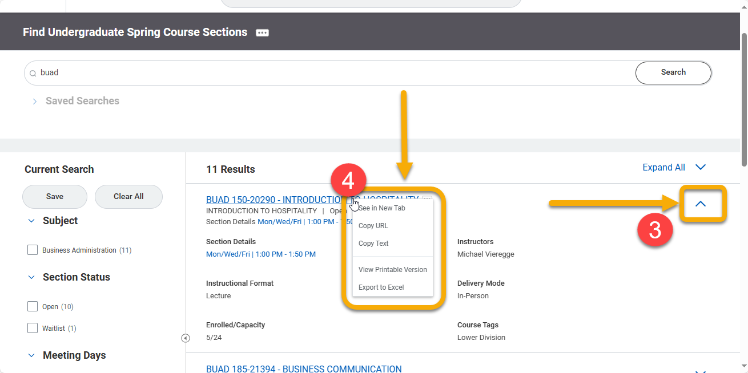

TIP: By opening the course in a new tab, you can easily close the window when finished and return to your search results.

- The View Course Section page displays all relevant course information. Important highlights are below:
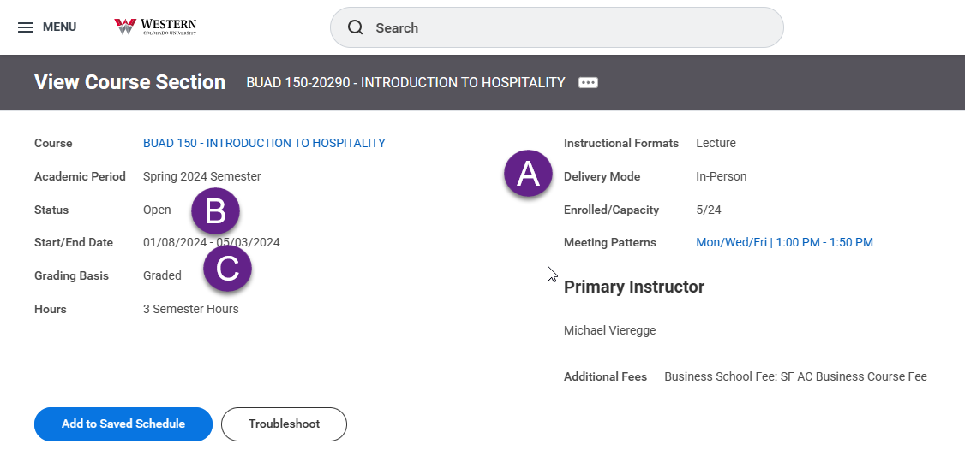
- Instructional format indicates whether the section is a lecture or lab.

- Status indicates whether the course has reached capacity. It will display either Open or Waitlist.

- Grading basis distinguishes a course as graded or pass/fail.

When the registration window is open, the blue “Register” button is visible for students.

When registration is closed, the page will display the “Add to Saved Schedule” button and “Troubleshoot” button.

TIP: Students right-click “Troubleshoot” to confirm they meet course requirements. If they don’t meet the prerequisites, they may ask for an exemption by submitting a course section prerequisite override.

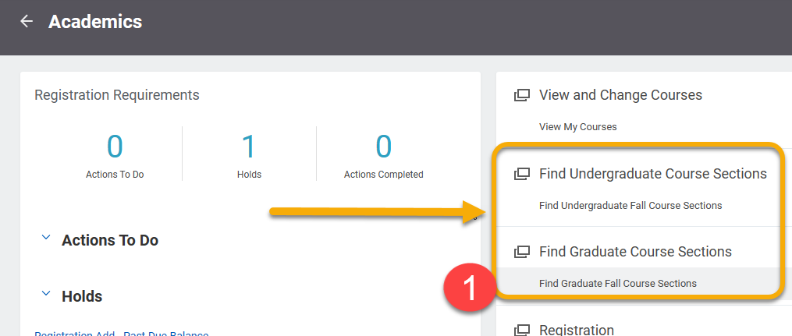
TIP: The process to find course sections is similar for students. To access the Find Course Sections page, they click “Find Undergraduate/Graduate Course Sections” from their Academics app homepage.

